CMSC 335 Project 3 Submission

Benjamin Marquis

12/14/2021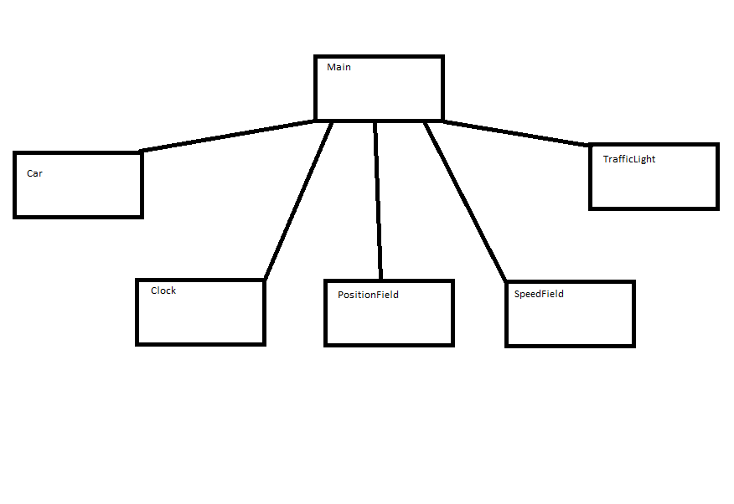

**Developer’s guide:**

This collection of Java files displays a map to the user that includes 3 traffic lights and 3 cars on a roadway.

The roadway is 1500 pixels long. Each pixel corresponds to 2 meters in distance. The cars travel at 100 m/s meaning they take 10 seconds to travel from one light to the next. The traffic signals are programmed to switch from green to yellow to red.

The cars in this program take up to 3 seconds to realize a light has turned from red to green. I almost fixed this to be instantaneous but I decided it was realistic and left it as is.

This program also includes a control panel for the user to see the speed and position of each vehicle at a given time. The control panel includes buttons to remove and add each car and light.

The program is run by running the Main.java file.

**Testing:**

**Normal operation**

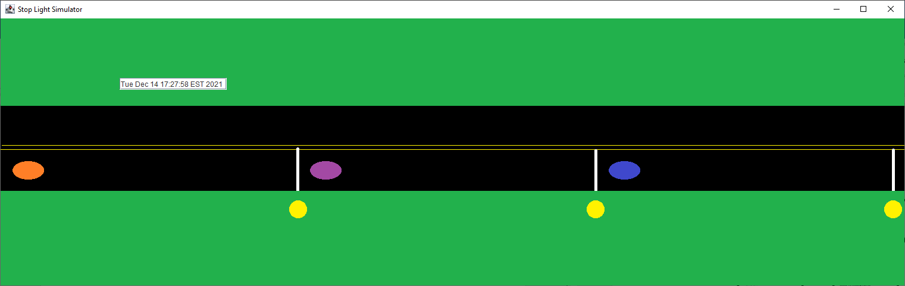

**Removed light**

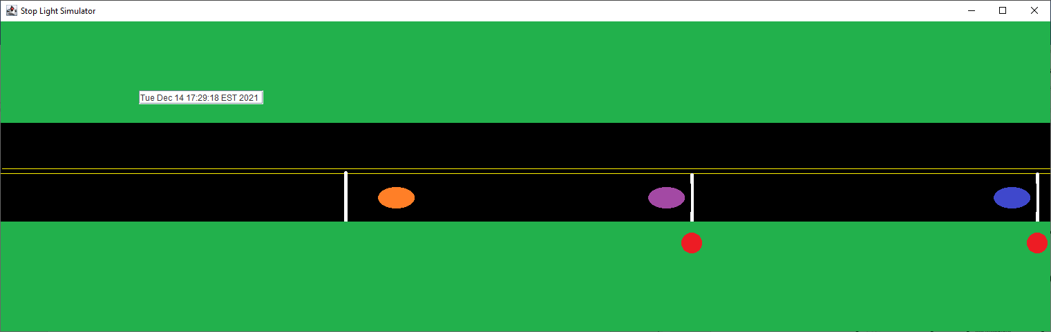

**Removed cars**

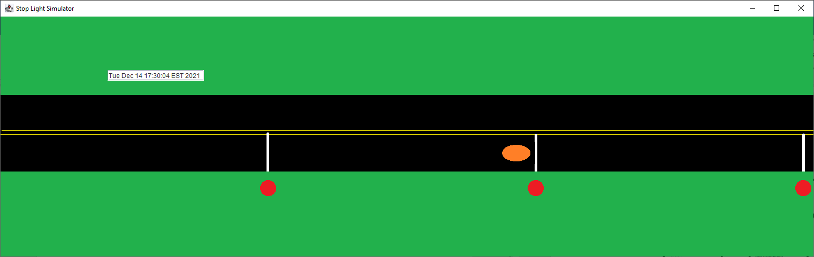

**Control Panel**

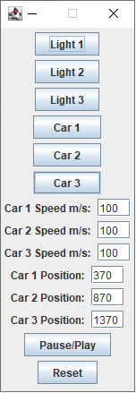

These tests demonstrate the functionality of the buttons and show that the program can add or remove cars and lights up to 3 of each.

**Limitations:**

Under some circumstances the behavior of cars at stop lights that have just reappeared after having been removed from the map is inconsistent. After the light has completed a full cycle the functionality of the cars and the light returns to normal.

**Lessons learned:**

This was an excellent exercise in getting threads to run simultaneously and also a refresher on GUI’s.

I had to use the null layout for getting the cars map and light to stay where I needed them. This was also a helpful exercise in learning.

I had to learn about atomic variables such as the atomic Boolean in order to get the cars to detect the color of the light and behave properly.

The reset button felt like a bit of a cop out but I did not have time to improve it. It currently functions by closing out of the experiment entirely and starting a new one. Ideally it would reset the cars to their original locations and move each stop light to the beginning of its red signal but I could not figure out how to end the threads for the stop lights and restart them from the beginning. This worked best.

Overall I’d say this was a massive learning experience. I gained helpful knowledge in the areas of threading and GUIs.